Exam 4/final exam topics list
- This exam will cover topics:
  - 20: kidney (lecture on D2L)
  - 21: CV part 1
  - 22: CV part 2
  - 23: CO and baroreceptor reflex
  - 24: pulmonary study guide: this final exam will only cover pages 1-4 of the Study Guide Topic 24.
  - 25: my recorded video of surface tension and pulmonary pressures (preppages.com)
This exam will have questions regarding my recorded videos and the drawings of surface tension and pulmonary pressure.

- Which of the following lists the correct three layers of the glomerular filtration membrane in order from blood → filtrate?
- What structure contains fenestrations that allow plasma to filter but block blood cells?
- Which part of the nephron is permeable to water but not solutes?
- NKCC2 is located in which part of the nephron?
- ADH and aquaporins
- myogenic mechanism (describe/broad definition)
- Which correctly describes a major effect of PTH in the kidney? Calcium? Increase Decrease?
- GFR numbers for normal filtration vs. those with kidney disease – actual values
- NFP: 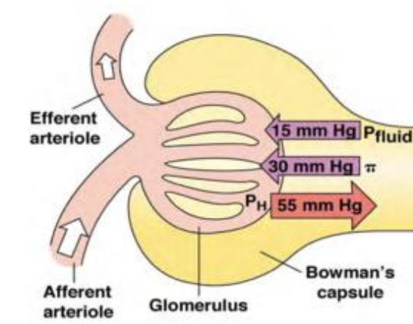
- 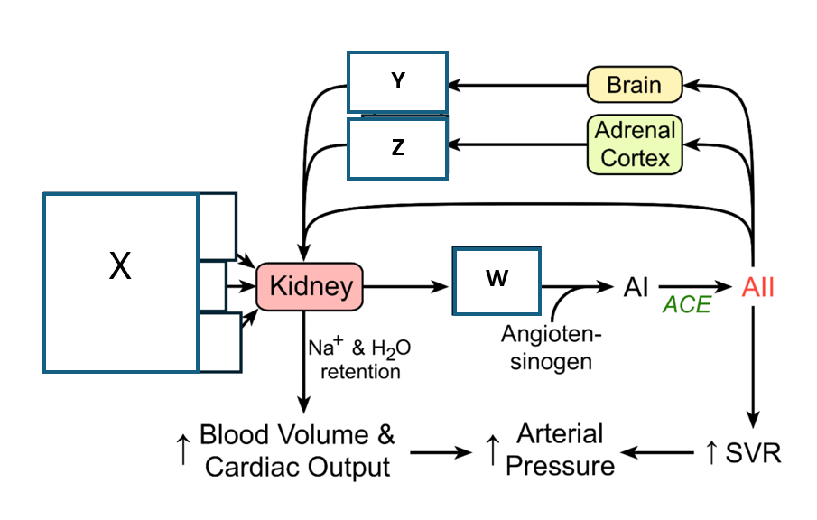identify//RAAS
- What is RAAS?
- Diabetes insipidus
- Identify: 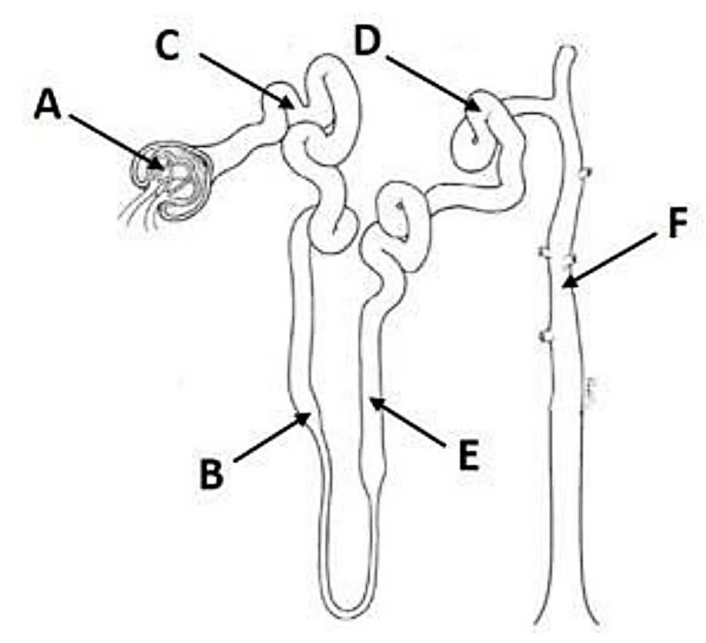
- What is the function of the Glomerulus, DCT, Loop of Henle, CD, PCT,
- Albumin
- Venous VS Atrial blood oxygen vs deoxygenated color of the blood
- Monocytes erythrocytes platelet’s and lymphocytes and which ones have and doesn’t have a nuclei vs mitochondria
- Pernicious anemia
- Universal donor vs receiver (blood)
- Hematopoietic stem cell
- Which of the following lists the correct order of red blood cell development from earliest to latest
- The first step in hemostasis after vessel damage 123 steps
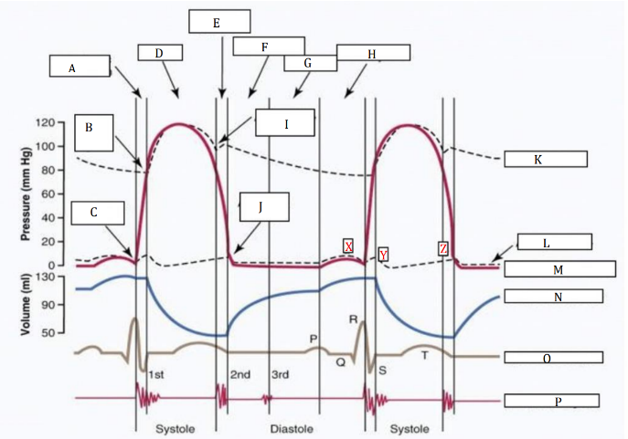
- Fibrinogen is converted to fibrin through which of the following mechanisms?
- EDTA
- The “lub” and “dub” heart sound corresponds to?
- Which of the following lists the correct sequential order of the cardiac cycle, beginning with ventricular filling and ending just before the next heartbeat?
- Which of the following correctly describes the complete directional order of blood flow beginning at the inferior and superior vena cava and ending as blood is pumped to the rest of the body?
- The interconnected structures that allow cardiac muscle cells to pass electrical impulses rapidly from cell to cell are called:
- Pacemaker potential occurs due to the spontaneous opening of which type of channels
- The plateau phase of a myocardial action potential is caused by a balance between:
- Atherosclerosis vs varicose veins vs DVT
- Capillaries and cross sectional area….
- Which part of the conduction system slows impulse conduction, creating a delay between atrial and ventricular contraction?
- The region of cardiac tissue that contracts together in response to a single stimulation event is known as the:
- A third-degree AV block is characterized by:
- Veins return blood to the heart with the help of?
- 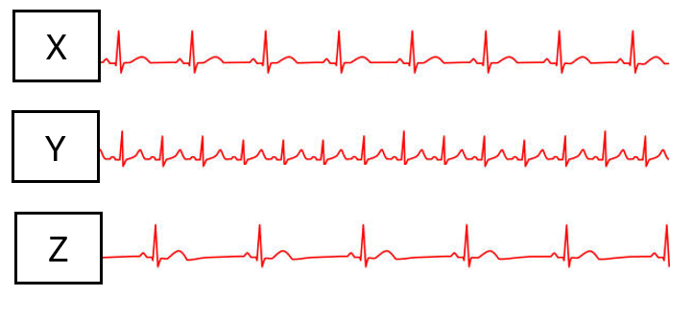
- R-R interval
- P-wave, QRS, t-wave which goes to ventricular vs atrial depolarization
- Stroke volume represents:
- 3 parameters that make up SV
- Define: preload, afterload, contractility
- TPR (define)
- CO (define)
- CO formula
- Primary vs secondary hypertension
- Define conducting vs respiratory ZONES
- Mucociliary escalator
- Type 1 vs type 2 alveolar cells (aka pneumocytes)
- Quiet inspiration vs Quiet expiration
  - What happens to the diaphragm
  - What happens to the volume inside the thoracic cavity
  - What happenes to the pressure changes
  - What happens to the intercostal muscles
  - Are muscles recuieted
  - Are strectch receptors initiated
  - If Stretch receptors are then does that increase or decrease Action potentials to the brain, and what part of the brain
- Surfactact
  - What is is make up of
  - What does it do
- What is air made up of
  - What percentage of nitrogen vs oxygen
- Intrapleural pressure
  - What is the normal pressure # and is it positive or negative
  - Where does the pressure come from
  - What are the four factors that make up and contribute to this pressure
- Disease caused by lack of surfactant in premature babies
- Pulmonary edema
  - Build up of water … where though???
- What is the Rule of thumb for pressures when it comes to the thoracic cavity which is the reason why we can see the diagram say 760mmHg or 0mmHg for the intra-alveolar pressure.
- Location of the baroreceptors
- Baroreceptor reflex (define)
  - What happens if you increase or decrease BP what would be the compensation for increase vs decrease etc
- Label/identify
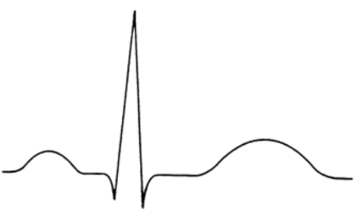
  - pqrst including segments and intervals

